Using the UCIPD SIG in SCoPE
Guideline prepared by E.Wallace, SFU ewallace@sfu.ca

A Special Interest Group (SIG) has been set up for the members of UCIPD on SFU’s platform for online communities of practice. The following is a guide for using the SIG:

- SCoPE (SFU’s Comunity of Practice for Educators) is an Open Source Moodle platform that can be viewed by anyone at http://scope.lidc.sfu.ca , but guests who want to post messages or contribute to the site must create a new account, using the link in the top right hand corner.

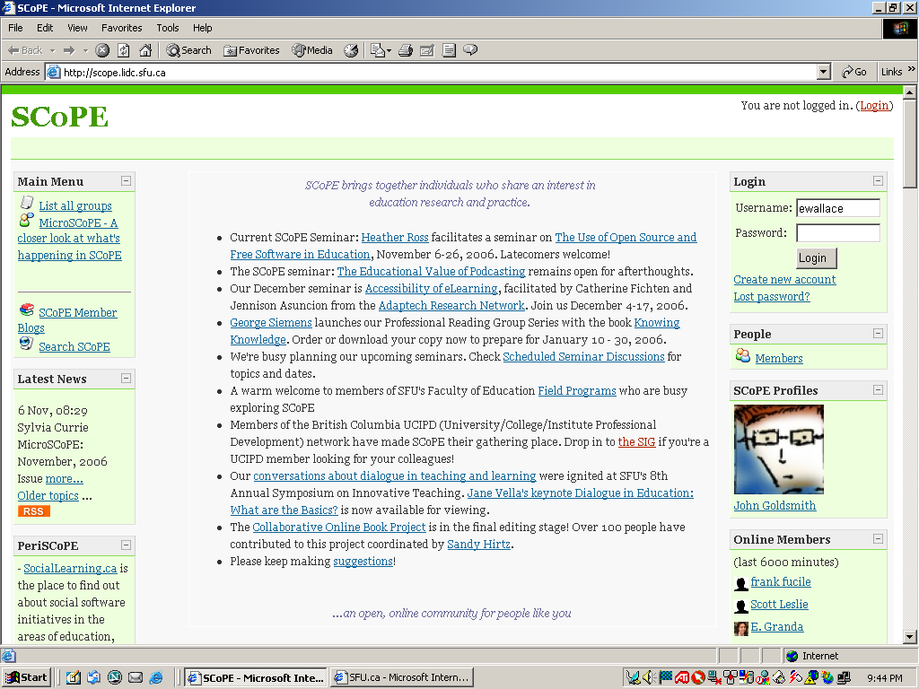

- In order to participate in the private UCIPD SIG, members need to be given access by the SCoPE administrators. Please send an email to ewallace@sfu.ca if you need access.
- Once you have been sent your Username and Password you can log in at the top right hand corner of the SCoPE Homepage, and go to the UCIPD Homepage.

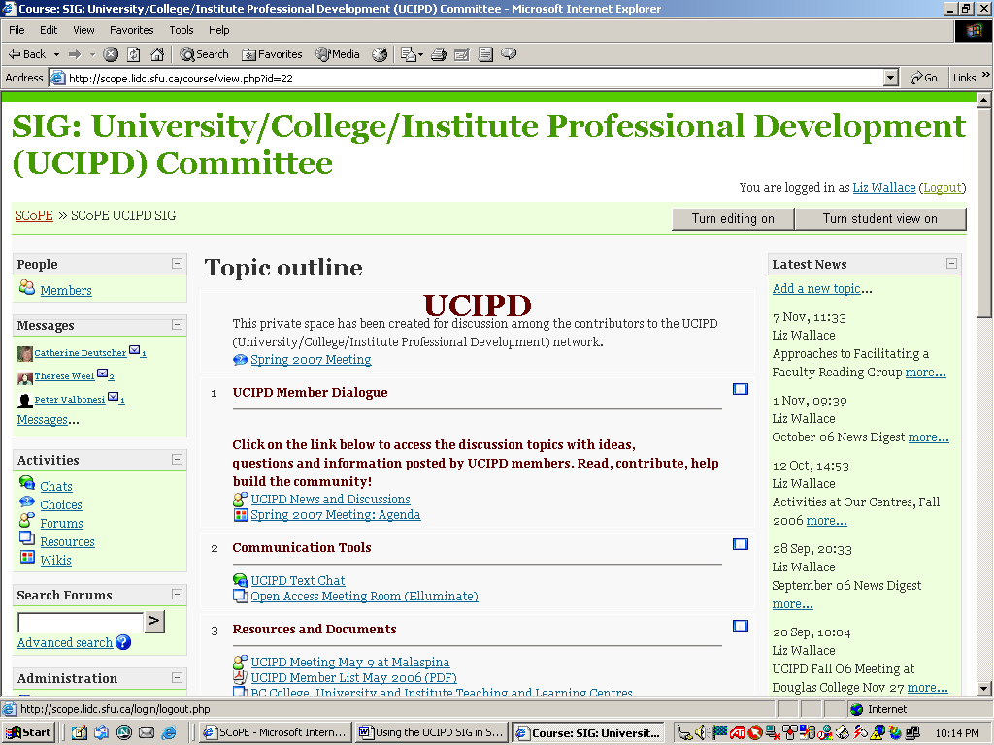

- The UCIPD site has three sections at present, although more can be added:
- UCIPD Member Dialogue
- UCIPD News and Discussion
- Communication Tools:
- UCIPD Text Chat
- Open Access Meeting Room (Elluminate eLIVE)
- Resources and Documents
- e.g. UCIPD Meeting notes

- The forums for discussion are located under UCIPD News and Discussions:

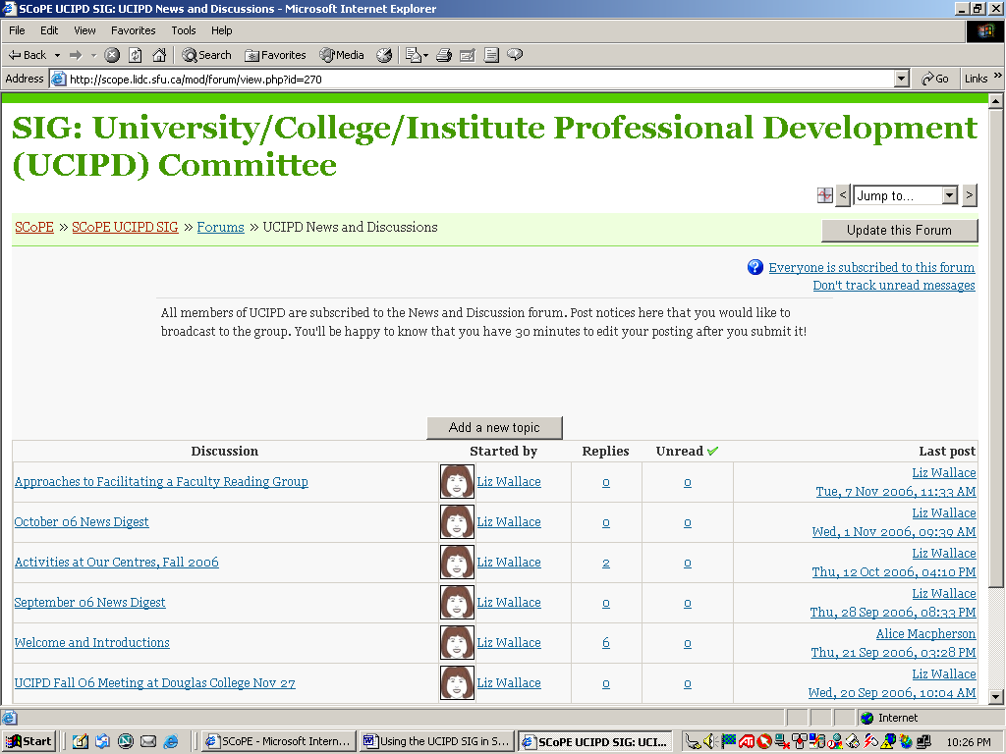

- Click on an existing topic to see the thread. (You can also add a new topic):

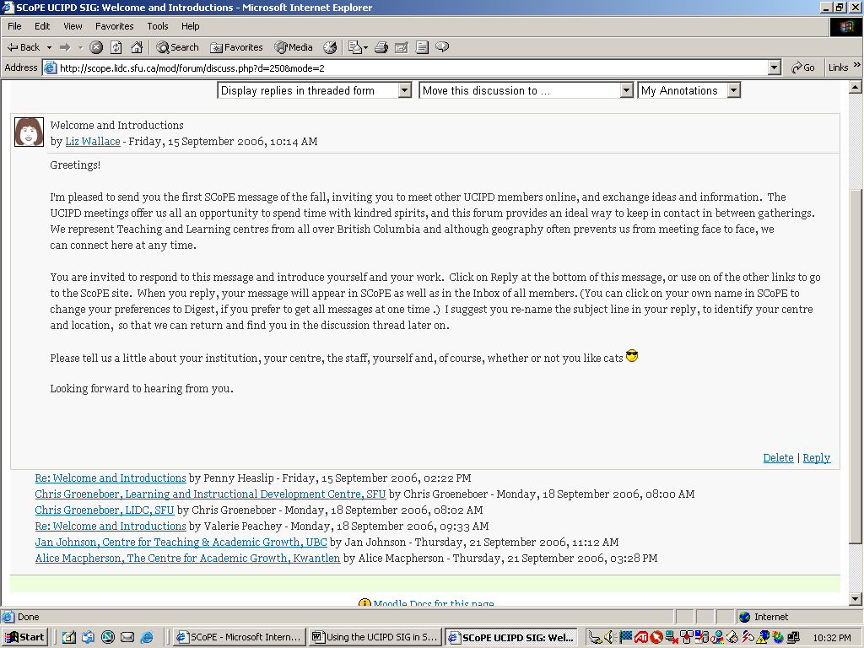

- Click on Reply in any posting to add your own comments. Images and formatting can be included, and files can be attached. After you have pressed “Post to Forum” you have 30 minutes to edit what you have written before it is displayed for other members to see:

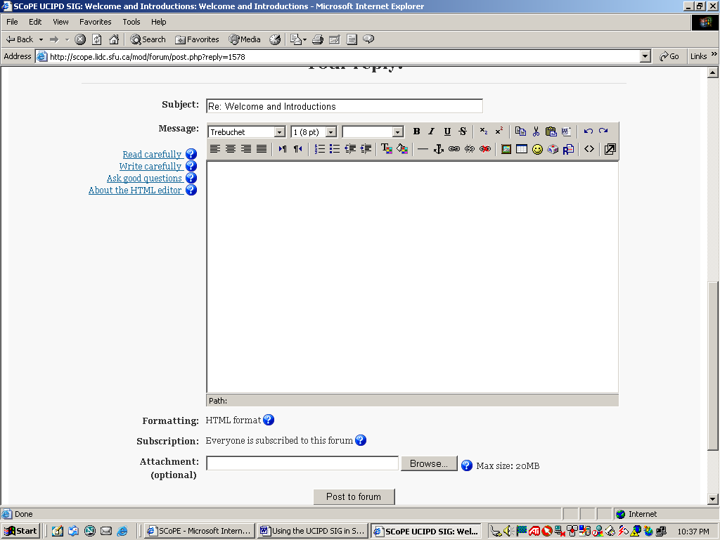

- As well as appearing on the SCoPE site, your posting will be sent to the regular Inbox of members, using the email that they had used to create a Username. Members can set change their settings so that messages are received in their Inboxes as soon as they are posted, or in a daily digest…or not at all! Members can Reply to postings directly from their Inboxes, and will be prompted to log on to SCoPE.
- There are over 300 international members in SCoPE, participating in a variety of Open Forums and scheduled seminars. UCIPD members have access to all those activities, except for other private SIGS.

SCoPE Project Leader: Elizabeth Wallace
SCoPE Co-ordinator: Sylvia Currie

