FLO MicroCourse - Creating and Using Rubrics: Tools and Resources

September 2018
This is a collection of tools and resources compiled for and by participants in the FLO MicroCourse - Creating and Using Rubrics.

Feel free to add to the lists!

Reading about rubrics
- Assessing Online Participation: Exploring the Problem & Possible Solutions
https://scope.bccampus.ca/pluginfile.php/58262/mod_book/chapter/2855/Assessing_Participation.pdf

- Creating a Rubric: Online Tutorial for Faculty from University of Colorado Denver:
http://www.ucdenver.edu/faculty_staff/faculty/center-for-faculty-development/Documents/Tutorials/Rubrics/index.htm

- Overview of Rubrics, types, creation and evaluation of from DePaul University: https://resources.depaul.edu/teaching-commons/teaching-guides/feedback-grading/rubrics/Pages/default.aspx

- Know your terms: holistic, analytic, and single point rubrics
https://www.cultofpedagogy.com/holistic-analytic-single-point-rubrics/

- Your rubric is a hot mess; here’s how to fix it
http://www.brilliant-insane.com/2014/10/single-point-rubric.html
- Know Your Terms: Holistic, Analytic, and Single-Point Rubrics
https://www.cultofpedagogy.com/holistic-analytic-single-point-rubrics/
- Single Point Rubric: A Tool for Responsible Student Self-Assessment
https://digitalcommons.unomaha.edu/cgi/viewcontent.cgi?referer=&httpsredir=1&article=1004&context=tedfacpub

- Introduction to Rubrics Workshop PowerPoint
https://chfasoa.uni.edu/IntroductiontoRubrics.pdf

- Introduction to Rubrics (PDF)
http://www.humber.ca/centreforteachingandlearning/assets/files/Teaching%20Resources/Intro%20to%20Rubrics(2).pdf

- Course Development Tools: Rubrics
http://www.humber.ca/centreforteachingandlearning/instructional-strategies/teaching-methods/course-development-tools/creating-assignment-rubrics.html

- Assessment and Rubrics: Kathy Schrock’s Guide to Everything
http://www.schrockguide.net/assessment-and-rubrics.html

- Quality of Teaching and Learning Online: University of California (Chico) Exemplary http://www.csuchico.edu/eoi/

Research on the use of rubrics
- Scaffolding Rubrics to Improve Student Writing (PDF)
https://res.mdpi.com/societies/societies-08-00034/article_deploy/societies-08-00034.pdf?filename=&attachment=1

Resources to help students understand and use rubrics
- A video developed by Christina Page at KPU for students to to understand rubrics in order to support their work https://youtu.be/o3azI54uQmE

Rubric repositories
- http://course1.winona.edu/shatfield/air/rubrics.htm
- https://www.aacu.org/value/rubrics
- University of Wisconsin Stout, Examples of Rubrics:
- Presentations, Social Media Projects, Discussion, Teamwork, Groupwork, ePortfolio and Web Page, Concept Map and Graphic Organizer, Video and Multimedia, Virtual Simulations and Games, Research Process, Writing, Math and Science
  - https://wwwcs.uwstout.edu/soe/profdev/rubrics.cfm

Rubrics for creating rubrics
- https://ciel.viu.ca/teaching-learning-pedagogy/designing-your-course/building-useful-rubrics/rubric-quality-rubrics This is a very comprehensive rubric to guide the process of building useful rubrics. It was developed by Vancouver Island University and includes a handout.

Online tools to generate rubrics
- http://rubistar.4teachers.org/index.php This free tool requires an account (quick process) and from there you choose from a list of customizable rubrics, or you can start from scratch. If you can see past the advertising and the colour scheme of the website, it’s not a bad tool!
- https://www.rcampus.com/indexrubric.cfm You can develop and share the rubric from this platform. It is especially useful for using rubrics with a scoring system.

Rubric Humour
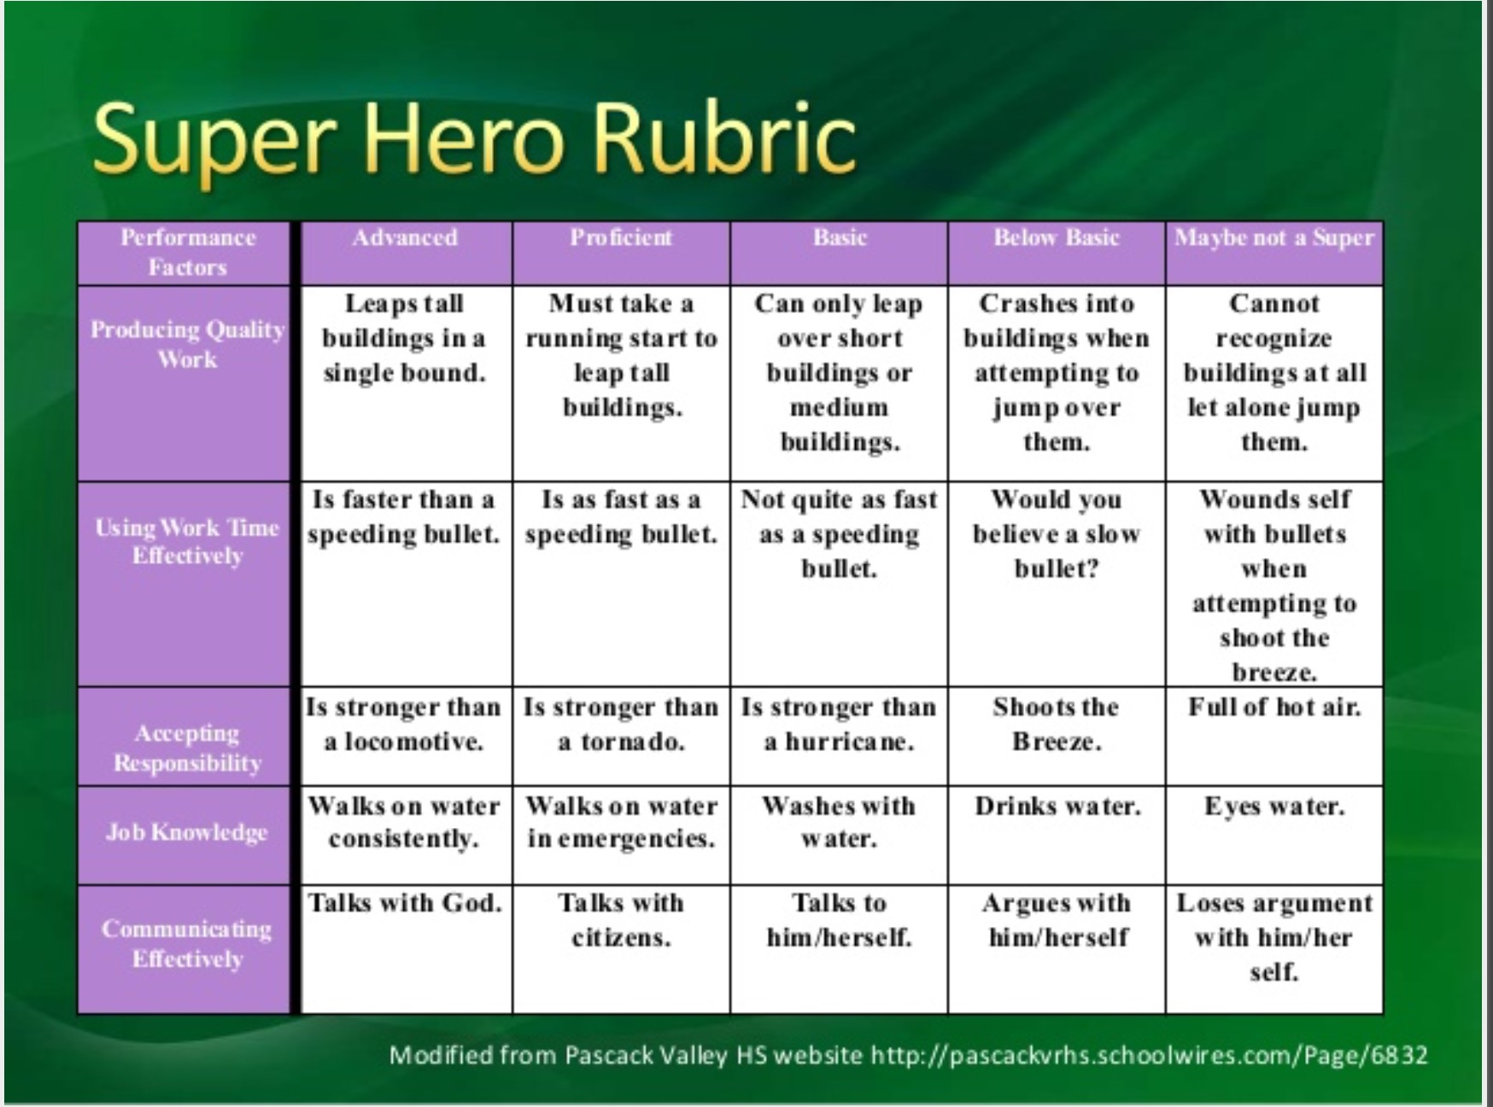
Source: https://www.slideshare.net/mobile/sbaule1/rubric-development-for-teachers (Slide 2 -- The best slide in the deck :-)

