Heather Smith – Activity 3 – Revised

Assessment title: Reigning in our inner squirrels

Assessment set up:

In setting up the assessment I’m going to share a couple of slides similar with photos such as these that represent the squirrel metaphor of engaging in one task and then being diverted by..an apple or another task…I’ll tell students that is how I feel sometimes when I sit down to do some concentrated reading or work. And even after decades (yes decades) of doing this kind of work …sometimes I get distract by the apple. But….over time I’ve learned how to regulate/modify/adapt my behaviours to achieve the outcomes I seek.

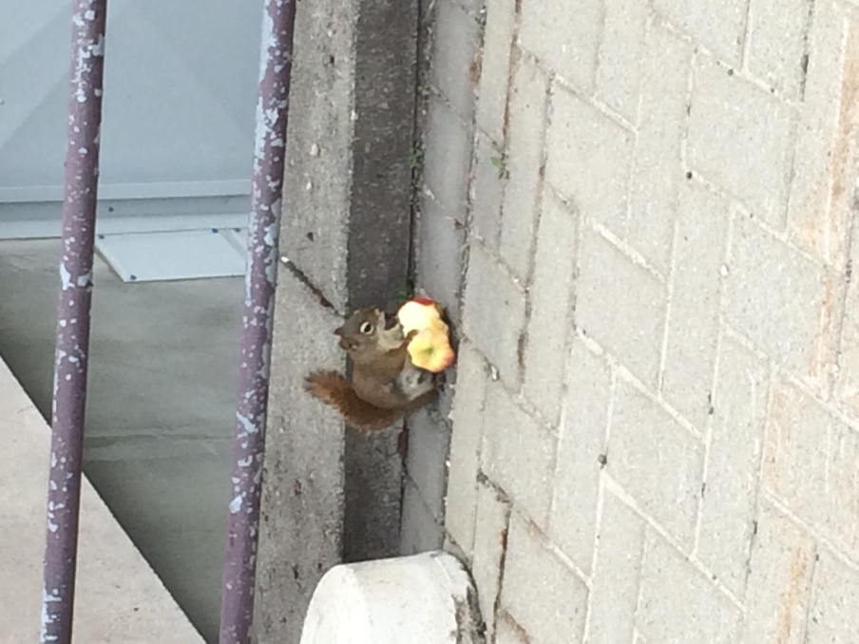

I’ll ask the students to send me photos/images (CC or their own images – those above are mine) and I’ll create a couple of power point slides of their images that represent how they feel about sitting down to read an academic article.

Class one set up:
Open with the images provided by the students of how they feel about sitting down to read an academic article – these would be scrolling – and they would be anomized. I’ll note that we may all have different experiences, and different processes, but we can learn from each other and we can all work to identify the best practices.

Objectives: by the end of these series of lessons students will have collaboratively created a check list for themselves of best practices that can guide their effective and efficient reading of academic articles.

Why do this: As you move through your academic careers, and beyond, the ability to effectively and often efficiently read an academic article for its thesis statement and key arguments is an essential skill. It’s also great to take the time to reflect on the ‘so what and who cares’ of the article … why does it matter, to whom does it matter, in what context? By doing this exercise we engage in an explicit discussion of our processes and are able to identify strategies that build positive outcomes.

Timeline of the assignment:
Tuesday January 15 (I’ve made up these dates for the purpose here…):
- Let’s begin with some individual reflection on the following question: “What do you do look for when you read an academic article?” Please write each step/action down on a single big post-it note. (10 minutes)
- Now, in groups of 5 – come together and put your post-it notes in logical categories and make sure you label those categories (15 minutes)
- Now compare your categories and criteria with another group. What did you have that was similar? What was different? What would you keep from each? (15 minutes)
- The instructor will then share her step by step process for reading an academic article using a reading from that week. (20 minutes)
- Group discussion – is there anything from my modelling of my process that is similar to or different from your process? Are there elements missing from our categories? Anything you must include? Anything you think is contingent on your own preferences? (20 minutes)
- Together we will revise the checklist of preferences and must do’s and plan to give it a test run in the next class.

Thursday January 17 – testing our check list for best practices
- Coming to class having read the assigned article, working in groups, the students apply the ‘must do’s’ to the article and document their responses on the class blog (20 minutes)
- We will then mix up the groups and have the students provide feedback to each other on the responses they’ve provided. (20 minutes)
- We will collaboratively review the checklist of best practices and reflect on whether or not there is anything missing from our checklist, whether or not the template needs revision and why and how the process can benefit us as we move through the course (and other courses) (20 minutes)

I’ll also make sure there are resources to students to review in advance and use visuals in class to work through the process.

Original
Heather Smith Activity 2 – Assignment

Context:
Last year I taught a course at a 3rd year level at Dalhousie. The students were used to large lecture classes and so the active learning turn in my class was faced with a lot of a resistance. Some, of course, loved it…while other actively … and I mean actively….disengaged and thought it was ‘unscholarly’. I’m teaching it again in the winter semester and want to try to sort of ‘start where the students are at’ and I was inspired by the discussion in the Cummingham (2018) piece about how you can take a horse to water but you can’t make them drink…but you can salt the oats. I’ve been wondering about how to ‘salt the oats’ for these students.

One of the areas in which their skills were quite varied and which many assumed they have strong skills was the ability to read an academic article for its thesis statement and key arguments but it was clear that many didn’t have the skills they thought they had. Many also struggled with the ability to extrapolate arguments or envision consequences of the arguments beyond the text itself.

With that in mind, I thought I’d use some class time to explicitly work through this skill with them and to have them work individually and collaboratively on the skill. I suspect it will take a couple of classes to do this and I will need to figure out how to include that smoothly into the class (so any suggestions on that front are welcome…I tend to do mini-lectures and activities on one day of the class and dedicate the second day of the class in a given week to hands-on).

So here’s the rough idea….

Title: Unpacking the process of reading an academic article

Objectives: by the end of these series of lessons students will have collaboratively created a template that can guide their effective and efficient reading of academic articles.

Why do this: As you move through your academic careers, and beyond, the ability to effectively and often efficiently read an academic article for its thesis statement and key arguments is an essential skill. It’s also great to take the time to reflect on the ‘so what and who cares’ of the article … why does it matter, to whom does it matter, in what context?

Timeline of the assignment:
Tuesday January 15 (I’ve made up these dates for the purpose here…):
- We will begin the class with doing a collaborative brain storming session on the strategies you use to read academic articles for their thesis statements, key arguments, and the ‘so what and how cares’ questions. (20 minutes)
- We will then collect the ideas and start to create our template.
- The instructor will then share her step by step process for reading an academic article using a reading from that week. (20 minutes)
- Together we will revise the template and a plan to give it a test run in the next class.

Thursday January 17 – testing our template
- Working in groups, the students will fill out the template for the effective and efficient reading of an academic article based on one of the assigned readings for that class (20 minutes)
- We will then mix up the groups and have the students provide feedback to each other on the responses they’ve provided. (20 minutes)
- We will collaboratively review the templates and reflect on whether or not there is anything missing from our templates, whether or not the template needs revision and why and how the process can benefit us as we move through the course (and other courses) (20 minutes)
- Close with a one-minute essay on what the students learned about their own approaches to reading academic articles. (5 minutes)

