 | Graphics (each one linked to the wiki) | Question: from prescriptive <to> emergent <to> chaos | Range/Description: Across a spectrum from prescriptive <to> emergent <to> chaos | My Comments: How did this factor affect me and my learning?
Cluster:  Open / Structure |  | What is the balance between Openness and Structure? | Highly structured process and content < > very open with light-touch support
Factors … |  |  |  | Examples …
Risk |  | How safe, or how hazardous is the learning? | Fail-safe < .. > Safe-to-fail  < .. > High-risk
Liminal Space |  | Is there: no space/ a lot of space/ too much space for exploring and creating new roles and capabilities? | Conservative, fixed roles  < .. > Personal Growth < .. > Transformation, and creating new roles
Unpredict-able Outcomes |  | How fixed or unpredictable are the learning outcomes? | Fixed, micro-managed outcomes < .. > Derivative (new) outcomes < .. > Surprising, serendipitous, unpredictable outcomes
Ambiguity |  | How tightly defined, or open is the meaning and application the learning? | Closely defined meaning < .. > Negotiated meaning < .. > Open to several, simultaneous meanings
Disruption | 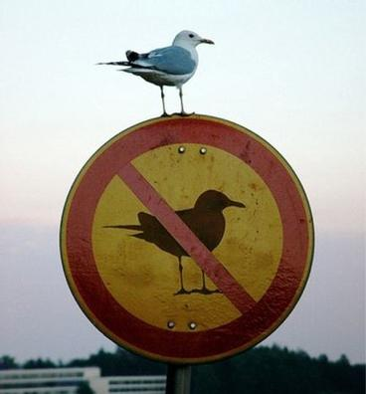 | How challenging or comfortable is the learning? | Comfort, familiarity < .. > Unsettling < .. > Challenging, provocative
Self-correction |  | Is the course / event self-correcting (e.g. wikipedia), or does it require on-going, centralised control? | Hierarchical control < .. > Learner input < .. > Self-correcting systems
Multipath |  | Is there only one learning pathway, or are many pathways possible? | Single pathway < .. > Limited variance < .. > Multiple, open, options …

 |  | Graphics (each one linked to the wiki) | Question: from prescriptive <to> emergent <to> chaos | Range/Description: Across a spectrum from prescriptive <to> emergent <to> chaos | My Comments: How did this factor affect me and my learning?
Cluster:  Inter-active  Environment |  |  | How is the learning design implemented? | Predetermined < .. > Open and emergent
Factors …
Diversity |  |  | Is the course designed around a few, key texts and people, or a wide and open range? | Standardised resources and experts < .. > Alternatives < .. > Open-ended range of resources
Experiential |  |  | How abstract and theoretical, or contextualised and practical is the learning? | Objective, abstract < ... > Scenarios < … > Embodied, immersed, practice-based learning
Adaptive |  |  | Is the course fixed, or responsive to new ideas, outcomes and process? | Fixed < ... > Amendments considered < ... > Responsive to innovative, creative change
Co-evolution |  | 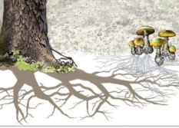 | Is the course independent of learner initiative, or does it grow and adapt with the learners? | Fixed, hierarchical relationships < ... > Mutual adaptation and growth
Interaction/  Networking |  | 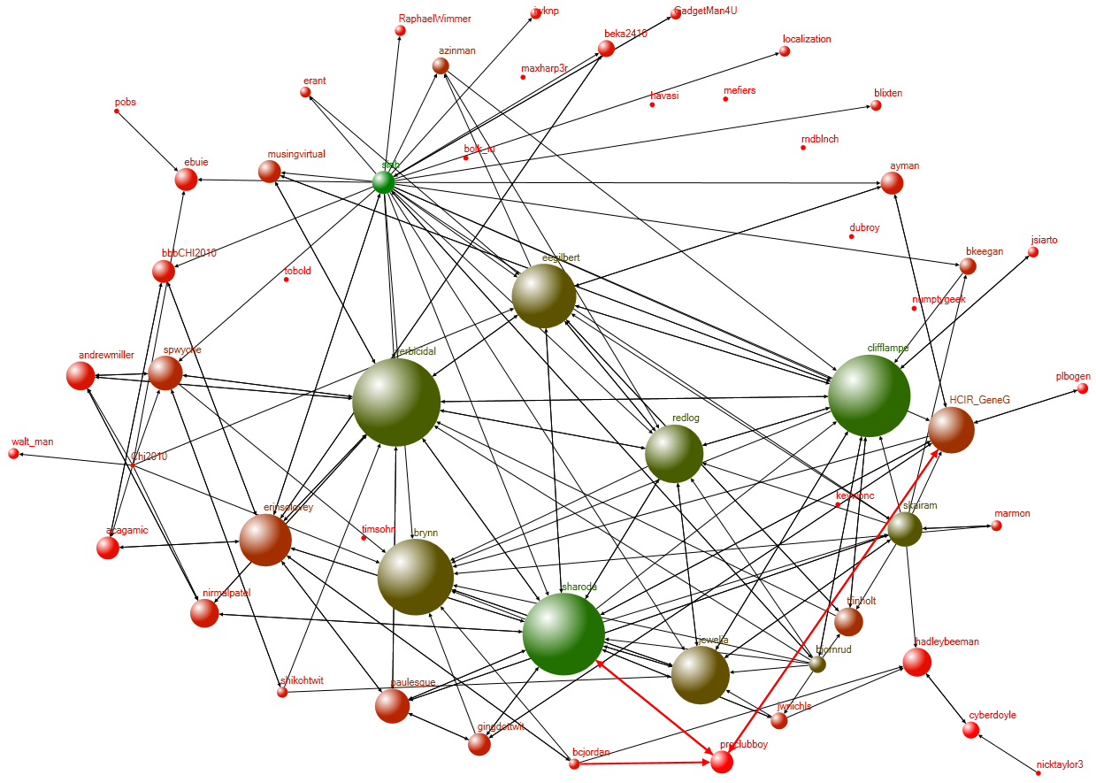 | Is the learning space confined to a particular institution, or does it connect easily to other learning spaces? | Bounded ('walled garden') learning space < ... > Informal networking < … > Open, diverse networked learning incorporated in process and outcomes
Trust |  |  | Is mutual tolerance and support critical to learning, or is learning entirely individual? | Competitive self-interest  < ... > Mutual respect, support and growth
Theory of Mind |  | 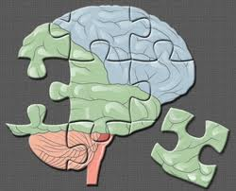 | Is it critical for learners to anticipate what other people (or interfaces) are 'thinking', or not? | Interacting with fixed texts < ... > Mutual conversations < … > Anticipating with what other 'minds' are thinking, and the next move … | N/A
 | Graphics (each one linked to the wiki,) |  | Question: from prescriptive <to> emergent <to> chaos | Range/Description: Across a spectrum from prescriptive <to> emergent <to> chaos | My Comments: How did this factor affect me and my learning?
Cluster:  Agency |  |  | Do learners develop their own capacity for action, or just compliance with given roles? | Compliance < … > independent initiative an personal development.
Factors …
Cross-modal | ’Kiki’ /or / ’Buba’ ? |  | Does the learning occur within a single mode (e.g. text, audio, graphics), or across many different modes? | Mono-modal, abstract interaction < ... > Different modes used < … > Embodied, holistic interaction; progression across more modes / levels of abstraction
Open Affordances |  |  | Is the creation of new outcomes and goals encouraged, or only pre-determined compliance? | Predetermined inter/action < ... > Room for exploration < … > Creative, innovative engagement.
Self-organisation | 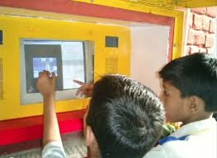 |  | Does the learning include the creation and organization of the learners' own processes, resources and networks? | Hierarchical, fixed processes < ... > Limited choices for personalization < … > Creative self-organization / self-motivation inherent in course design.
Autonomy |  |  | How much choice do learners have to create their own learning paths? | Working to given agendas and frameworks < ... > Creating your own agenda and goals.
Negotiated Outcomes ? |  |  | Are the outcomes fixed or negotiable? | Externally determined success factors < ... > Mutually determined success factors.
Identity |  |  | Is the development of new (or expanded) roles and capabilities part of the learning, or only fixed roles? | Complying with fixed roles < ... > Creating and developing your own roles, affordances, and capabilities

 | Graphics (each one linked to the wiki,) | Question: from prescriptive <to> emergent <to> chaos | Range/Description: Across a spectrum from prescriptive <to> emergent <to> chaos | My Comments: How did this factor affect me and my learning?
Cluster:  Presence/Writing |  | What traces do you make and leave behind you? | From chance, momentary traces to lasting images and impressions.
Factors …
Solitude and Contem-plation |  | Is the course schedule very busy and interactive, or does it incorporate space for quiet reflection? | Crowded inter/activity  < ... > Personal space for exploring, reflecting on and developing ideas, aspirations and values.
Casual/ Serendip-itous Encounters | 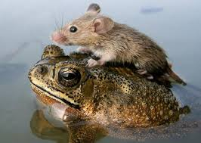 | Is all interaction formal and micro-managed, or is space also provided for casual encounters and conversations? | Highly formalised interaction < ... > Chance, serendipitous encounters
Networking, encounters, engagement |  | Does the learning include collaboration / cooperation in networks, beyond the course or event? | Formalised, fixed groups < ... > Initiating, creating, engaging with new contacts and groups.
Hybrid  Modes of  Writing |  | Is the ability to work in, and abstract from, several modes (text, visual, face-2-face) integral to the course? | Mono-media, mono-modal, abstract interaction < ... > Diversity, choice, and creativity in the use of media is encouraged.
In/fomal writing and inscription | 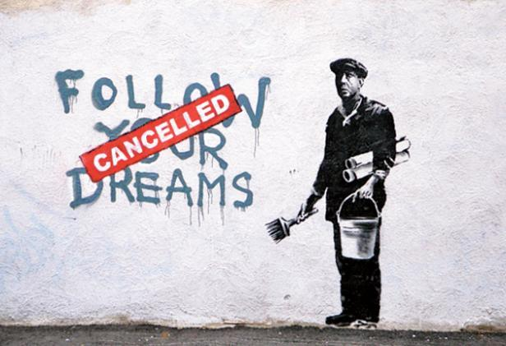 | Is range of forms of interaction, to develop ideas and perspectives, integral to the learning? | Engagement confined to formal, ritualized interaction and writing < ... > A range of writing, interacting and assessment artefacts and practices

