 | Graphics  (some with direct links to the wiki ) | Question: from prescriptive <to> emergent <to> chaos | Range/Description: Across a spectrum from prescriptive <to> emergent <to> chaos | My Comments: How did this factor affect me and my learning?
Cluster:  Open / Structure | 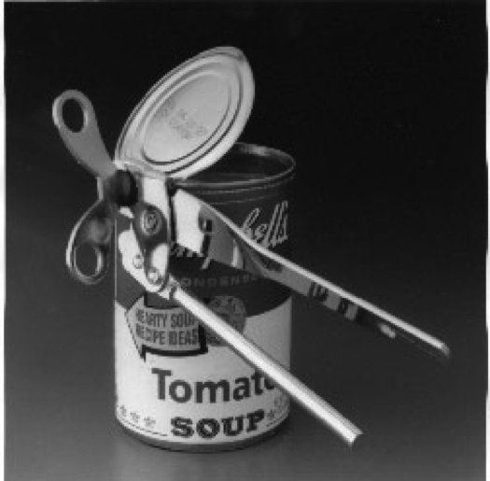 | What is the balance between Openness and Structure? | Highly structured process and content < > very open with light-touch support
Factors … |  |  |  | Barb’s Reflections 27.11.13
Risk |  | How safe, or how hazardous is the learning? | Fail-safe < .. > Safe-to-fail  < .. > High-risk | - Formal, graded course  - 500+ undergraduates  - will impact my transcript  - ages since formal training  - no base (year 1)  - no design skills with software  - timing – 6wks instead of 12  - just before going away so busy time
Liminal Space |  | Is there: no space/ a lot of space/ too much space for exploring and creating new roles and capabilities? | Conservative, fixed roles  < .. > Personal Growth < .. > Transformation, and creating new roles | - my role as student  - possibly a new role for me  - prescribed course outline  - time crnunch, pressure to satisfy requirements
Unpredict-able Outcomes |  | How fixed or unpredictable are the learning outcomes? | Fixed, micro-managed outcomes < .. > Derivative (new) outcomes < .. > Surprising, serendipitous, unpredictable outcomes | - fixed intended LOs  - made content relevant to my work  - explored only tools I was capable of using (may have been penalized e.g. googledocs VS illustrator)
Ambiguity |  | How tightly defined, or open is the meaning and application the learning? | Closely defined meaning < .. > Negotiated meaning < .. > Open to several, simultaneous meanings | - made content relevant  - used tools suited to my capability  - application and meaning broadly applicable
Disruption | 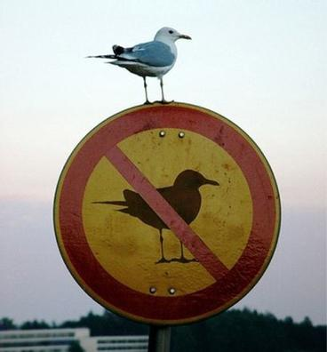 | How challenging or comfortable is the learning? | Comfort, familiarity < .. > Unsettling < .. > Challenging, provocative | - technical skills expectations were unrealistic so I made a decision on my own  - hated multiple choice exams – thinking too deep now as working adult  - frustrated by junior level and 500 students not guided in threaded discussion
Self-correction |  | Is the course / event self-correcting (e.g. wikipedia), or does it require on-going, centralised control? | Hierarchical control < .. > Learner input < .. > Self-correcting systems | - instructor controlled mostly  - made own decisions in terms of infographic and tools – likely was penalized for this
Multipath |  | Is there only one learning pathway, or are many pathways possible? | Single pathway < .. > Limited variance < .. > Multiple, open, options … | - one pathway overall although lots of room to experiment with tools

 |  | Graphics  (some with direct links to the wiki ) | Question: from prescriptive <to> emergent <to> chaos | Range/Description: Across a spectrum from prescriptive <to> emergent <to> chaos | My Comments: How did this factor affect me and my learning?
Cluster:  Inter-active  Environment |  |  | How is the learning design implemented? | Predetermined < .. > Open and emergent
Factors … |  |  |  |  | Barb’s comments 27.11.13
Diversity |  |  | Is the course designed around a few, key texts and people, or a wide and open range? | Standardised resources and experts < .. > Alternatives < .. > Open-ended range of resources | - selected by instructor but students could add their own in addition
Experiential |  |  | How abstract and theoretical, or contextualised and practical is the learning? | Objective, abstract < ... > Scenarios < … > Embodied, immersed, practice-based learning | - high activity requirements (all graded)  - chaotic participation with no guidance in threaded discussion (hundreds of meaningless comment)  - experiment at one’s peril in time – I went nuts with tools
Adaptive |  |  | Is the course fixed, or responsive to new ideas, outcomes and process? | Fixed < ... > Amendments considered < ... > Responsive to innovative, creative change | - fixed although instructor did gi ve me positive feedback on early infographic as lit review  - likely penalized for simple tool use
Co-evolution |  | 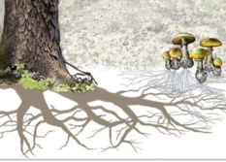 | Is the course independent of learner initiative, or does it grow and adapt with the learners? | Fixed, hierarchical relationships < ... > Mutual adaptation and growth | - pretty fixed and reflects 2nd year course among 500 paying students for credit
Interaction/  Networking |  | 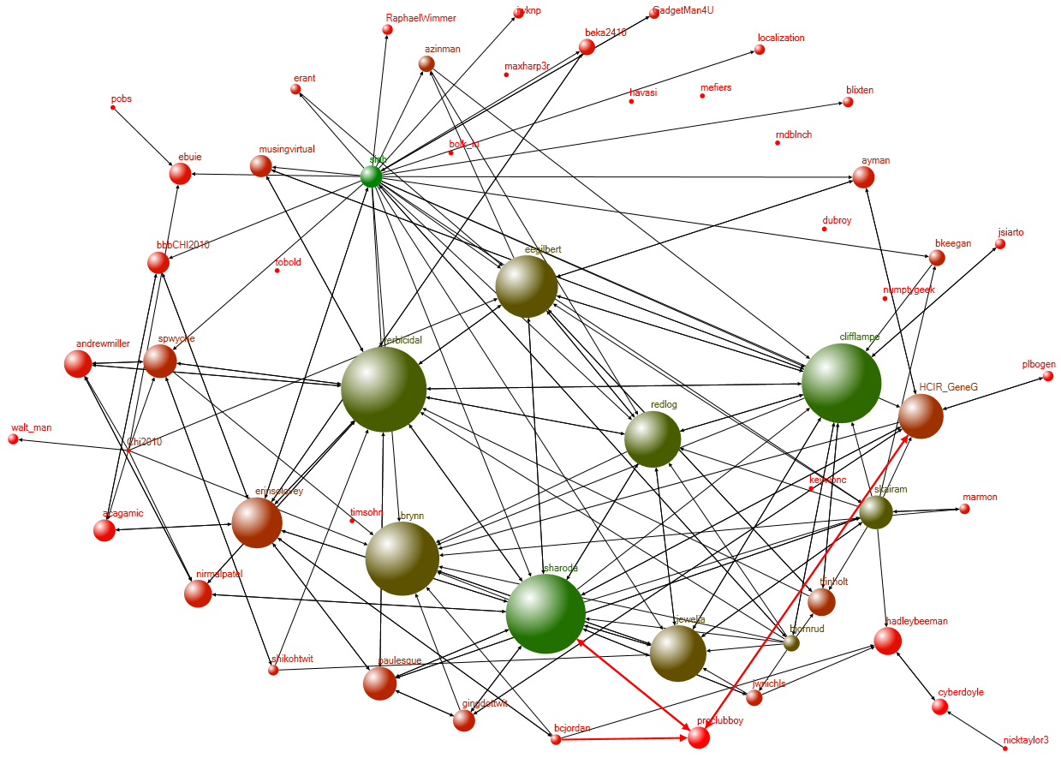 | Is the learning space confined to a particular institution, or does it connect easily to other learning spaces? | Bounded ('walled garden') learning space < ... > Informal networking < … > Open, diverse networked learning incorporated in process and outcomes | - 500 students  - out of control threaded discussion  - not much meaningmaking – weak pedagogic design  - lots of great options to engage/network
Trust |  |  | Is mutual tolerance and support critical to learning, or is learning entirely individual? | Competitive self-interest  < ... > Mutual respect, support and growth | - trusted instructor  - ?? trust among 500 students
Theory of Mind |  | 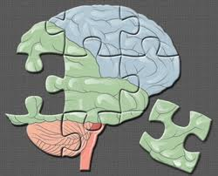 | Is it critical for learners to anticipate what other people (or interfaces) are 'thinking', or not? | Interacting with fixed texts < ... > Mutual conversations < … > Anticipating with what other 'minds' are thinking, and the next move … | - no idea – too much chaos with no or very little synthesis and guided reflection
 | Graphics  (some with direct links to the wiki ) |  | Question: from prescriptive <to> emergent <to> chaos | Range/Description: Across a spectrum from prescriptive <to> emergent <to> chaos | My Comments: How did this factor affect me and my learning?
Cluster:  Agency |  |  | Do learners develop their own capacity for action, or just compliance with given roles? | Compliance < … > independent initiative an personal development.
Factors …
Cross-modal | ’Kiki’ /or / ’Buba’ ? |  | Does the learning occur within a single mode (e.g. text, audio, graphics), or across many different modes? | Mono-modal, abstract interaction < ... > Different modes used < … > Embodied, holistic interaction; progression across more modes / levels of abstraction | - Yes, a variety of modes were possible (synchronous webinar with backchannel, threaded discussion, messages to instructor, visual, youtube, etc.)
Open Affordances |  |  | Is the creation of new outcomes and goals encouraged, or only pre-determined compliance? | Predetermined inter/action < ... > Room for exploration < … > Creative, innovative engagement. | - Fixed outcomes  - Through threaded people could pretty much get out of it what they out into it
Self-organisation | 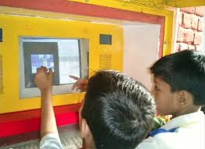 |  | Does the learning include the creation and organization of the learners' own processes, resources and networks? | Hierarchical, fixed processes < ... > Limited choices for personalization < … > Creative self-organization / self-motivation inherent in course design. | - It was possible to generate new contacts but in 500 and within constraints difficult to connect  - Too much difference between my needs and those of students
Autonomy |  |  | How much choice do learners have to create their own learning paths? | Working to given agendas and frameworks < ... > Creating your own agenda and goals. | - Not much choice here  - I tried to do my own thing but always within confines of the course requirements
Negotiated Outcomes ? |  |  | Are the outcomes fixed or negotiable? | Externally determined success factors < ... > Mutually determined success factors. | - no
Identity |  |  | Is the development of new (or expanded) roles and capabilities part of the learning, or only fixed roles? | Complying with fixed roles < ... > Creating and developing your own roles, affordances, and capabilities | - mostly fixed although I wore two “hats” – student and also designer as I was curious about how the course was designed

 | Graphics  (some with direct links to the wiki ) | Question: from prescriptive <to> emergent <to> chaos | Range/Description: Across a spectrum from prescriptive <to> emergent <to> chaos | My Comments: How did this factor affect me and my learning?
Cluster:  Presence/Writing |  | What traces do you make and leave behind you? | From chance, momentary traces to lasting images and impressions. | - Lots due to assignments and tasks from threaded discussion contributions to slideshare to infographic and exam results
Factors … |  |  |  | Barb’s comments 27.11.13
Solitude and Contem-plation |  | Is the course schedule very busy and interactive, or does it incorporate space for quiet reflection? | Crowded inter/activity  < ... > Personal space for exploring, reflecting on and developing ideas, aspirations and values. | - Condensed into 6 weeks from 12 – no time for reflection and no intentional guided reflection  - Threaded discussion may have been an attempt to do this but no guidance given
Casual/ Serendip-itous Encounters |  | Is all interaction formal and micro-managed, or is space also provided for casual encounters and conversations? | Highly formalised interaction < ... > Chance, serendipitous encounters | - Totally open in threaded although instructor was periodically present
Networking, encounters, engagement |  | Does the learning include collaboration / cooperation in networks, beyond the course or event? | Formalised, fixed groups < ... > Initiating, creating, engaging with new contacts and groups. | - Intermittent feedback to peers  - No groups or followup for me
Hybrid  Modes of  Writing |  | Is the ability to work in, and abstract from, several modes (text, visual, face-2-face) integral to the course? | Mono-media, mono-modal, abstract interaction < ... > Diversity, choice, and creativity in the use of media is encouraged. | - Mostly visual artifacts only text in threaded discussion, no writing activity to speak of in this course
In/fomal writing and inscription | 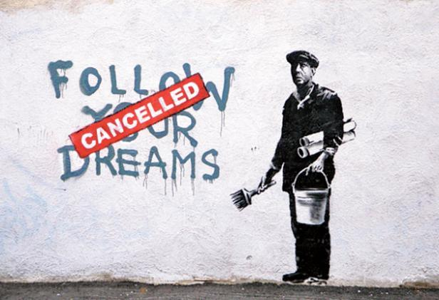 | Is range of forms of interaction, to develop ideas and perspectives, integral to the learning? | Engagement confined to formal, ritualized interaction and writing < ... > A range of writing, interacting and assessment artefacts and practices | - Random only, not intentionally designed for this nor was this my experience  - Too many students to do this in depth for meaning

