Qualitative E-Interview Tips

Choosing to Use Data Collected from Online Interviews
Why conduct interviews online?
One question in the E-Interview Framework (Salmons, 2012) is about researcher's motivations for collecting data through online interviews and the rationale for this choice in the context of the overall study. Two key factors are: 1) will the study use data collected through online interviews to investigate real-world, face-to-face phenomena? or 2) will the study use data collected through online interviews to investigate online phenomena?
Why conduct interviews online?
This question is discussed in depth in Chapter 1 of Online Interviews in Real Time (Salmons, 2010).
If we plan to interact online with a research participant because it is a convenient way to communicate and it allows us to interact with participants in broader geographic areas? If so, the choice of communications technology may be deferred to the participant: what tools are available and comfortable for interviewees? If the study requires data collected in a certain way, it may be important to check for access and ICT literacy needed by participants. It may be necessary to meet the participant for a trial run in advance of the interviews. For example, if the researcher wants to generate visual data the researcher may need to check whether the participant has a webcam, can use it, and is willing to appear on camera. Whatever ICT tool is used we may need to make note of the desired visual data in the informed consent form.
If we plan to interact online with a research participant because we are investigating online behaviors, we may want to use the same Information and Communication Technology tools for the interview. This can simplify the process since the a member of an online community or social media site would have the access, tools and skills needed to participate. If not, the same access and skills questions described above would apply. If you want to use the online community, virtual world or other site as the place where the interview will occur, you will need to make sure that is acceptable to the owner, moderator or the community members. Additionally, you will need to be sure the interview dialogue will be private and free of interruptions.
Another question to consider is the availability of user-posted information, including discussion posts, media or photographs in the online community, site or email list being studied. If such material, or observations of the participant's interactions with others, are to be used as data then they must be noted in the informed consent agreement.
The E-Interview Research Framework is presented as a circle because choices made in one area create new considerations in other areas. As this overview shows, the researcher's motivation to use data collected in online interviews has implications for ICT selection, timing, when a new tool must be introduced before the actual interview, as well as for items to include in the informed consent agreement. What are your design choices?

Think about your own design choices! This distinction is significant. How does your research purpose and motivation influence choice of technology tool, setting and ethical issues? Use the worksheet to note key elements of your study.

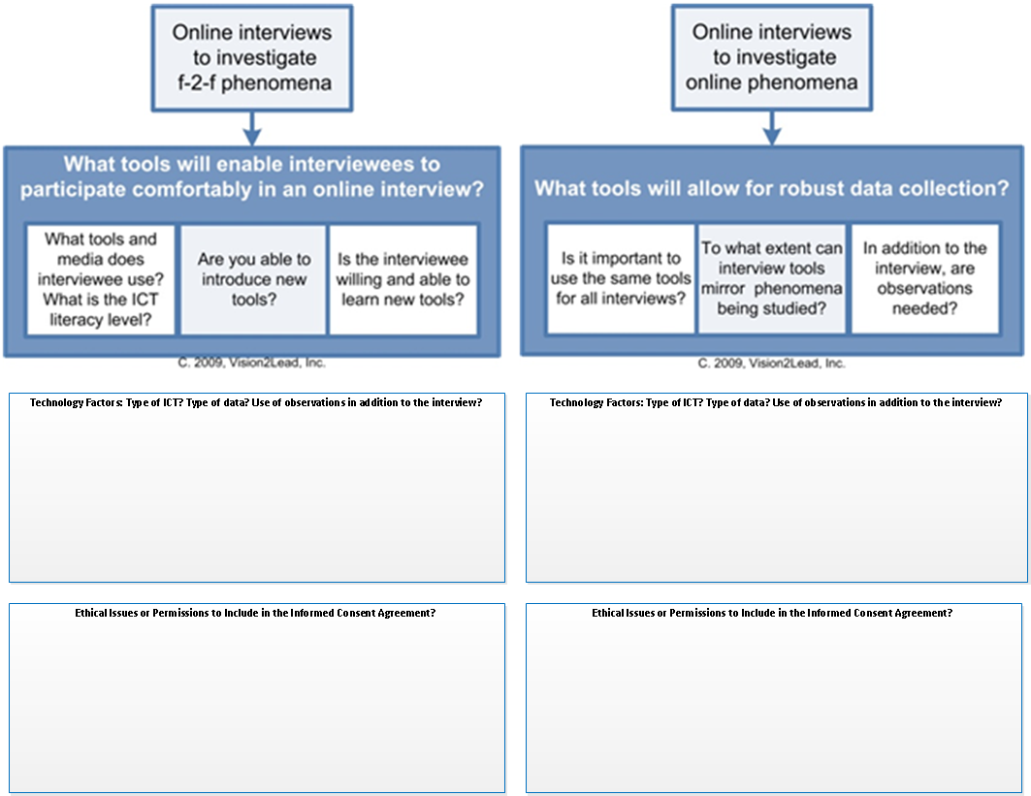

Salmons, J. E. (2010). Online Interviews in Real Time. Thousand Oaks: Sage Publications.
Salmons, J. E. (Ed.). (2012). Cases in online interview research. Thousand Oaks: Sage Publications.

