Qualitative E-Interview Tips

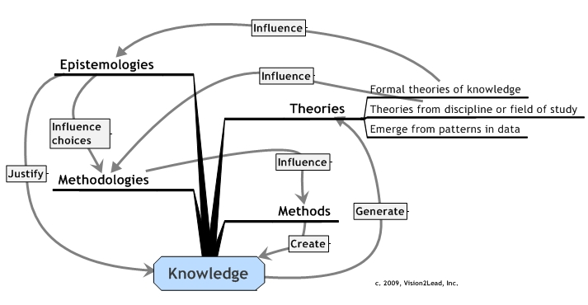**Mapping the Research Design**

An underlying principle for the approaches described in *Online Interviews in Real Time* and *Cases in Online Interviews in Real Time* is the need for alignment of research purpose, theories, methods and methodologies in the effort to create new knowledge. Such alignment is not unique to online interview research, however, a clear depiction of the design can strengthen the rationale for using online methods. This visual map shows relationships of these components in a research design.

Four inter-related facets of research are defined for our purposes as:

***Epistemology*** refers to the study of the nature of knowledge, or the study of how knowledge is justified;

***Theory*** refers to an explanation that is internally consistent, supportive of other theories, and gives new insights. An important characteristic of theory is that it is predictive.

***Methodology*** refers to the study of, and justification for the methods used to conduct the research (Gray, 2004). Methodologies emerged from academic disciplines in the social and physical sciences and, while considerable cross-disciplinary exchange occurs, choices generally place the study into a disciplinary context.

***Method*** refers to the practical steps used to conduct the study (Anfara & Mertz, 2006; Carter & Little, 2007) Interviews or observations are data collection methods.

**Map your own study design!** Use the Knowledge Map worksheet and visually describe key elements of your study.

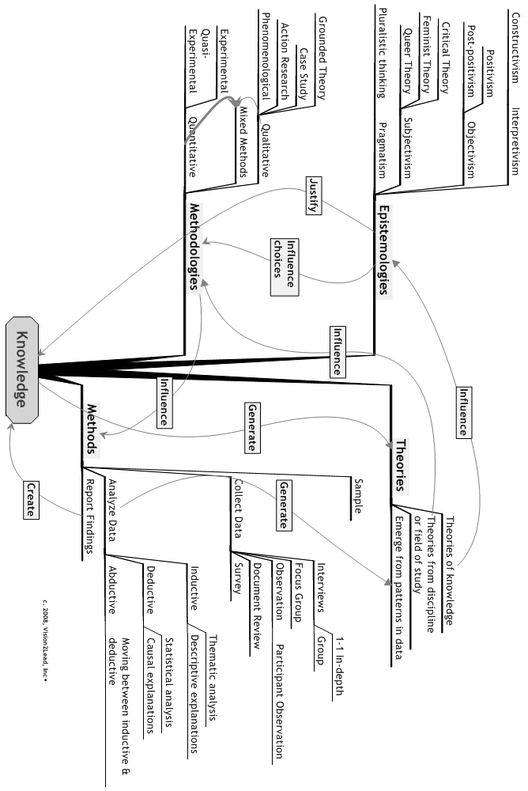

Methods

Methodology

Theories

Epistemology

Research question or problem?