Purpose
CoroCall is designed to run on a regular PC or Mac however, like most software applications there are minimum or even better recommended requirements to ensure your experience is optimal. If you comply with the following your experience should be fully satisfactory however, if you are not sure please contact us – see Contact Us.

PC
The machine should be a dual core processor and 2GB of RAM. To find out your system configuration …
Control Panel/System
Note while netbooks do not meet the aforementioned criteria the Intel Atom based processors work well.

Mac
The machine should be a dual core processor and 2GB of RAM. To find out how much RAM is installed …
Open the Apple menu (click on the little apple in the upper left corner of your screen), and choose either About This Macintosh or About This Computer. Look for the Total Memory line.
To find general information about your Mac …
Click the Apple in the upper left corner of the screen, and choose "About This Mac". That will show you a few basic details, but then clicking on "More Info..." in that window will open up System Profiler, which will show you all sorts of info about your system.
The OS should be at a minimum of OS Leopard 10.5. This can be verified by …
Click on the blue Apple icon in the left top corner and select "About This Mac". A small window will open showing a version of the system and the size of installed memory, which is also useful. See the screenshot on the right.
Note – pre OS X the method is different.

Audio/Visual Recommendations
It is strongly recommended that any external device be USB. Otherwise the device will use CPU cycles that may affect the overall performance.
Built in webcams work but often you will likely not experience the best results.
Audio – preferably use a USB connected headset or hands-free unit. Built in laptop/speaker combinations are problematic as they generate unwelcome echo. This can be mitigated by enabling echo cancelation but the audio experience will be affected. If you really have no option then even using ear bud headphones plugged into to the plugged into the 3.5mm female jack is a decent accommodation.

General Equipment Recommendations
The following is an example of equipment we have found useful and perform well but it is not meant to be a buy recommendation.
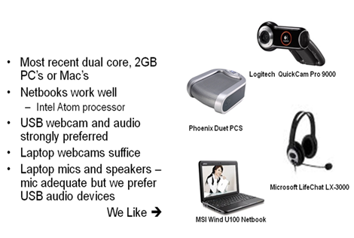

Network
While Wi-Fi works video likes bandwidth so if at all possible use a wired connection.
Minimum recommended network requirements:
- Upload 0,5MB
- Download 0,75MB
- Ping ≤ 50ms
Not sure? There are a number of network checking websites. An example is Speedtest. Using this site check the performance to Seattle (state of Washington in USA) as that is where our data center is located. The following example was for my desktop:
To set to Seatle move around the map and select the cityfrom the drop downs:
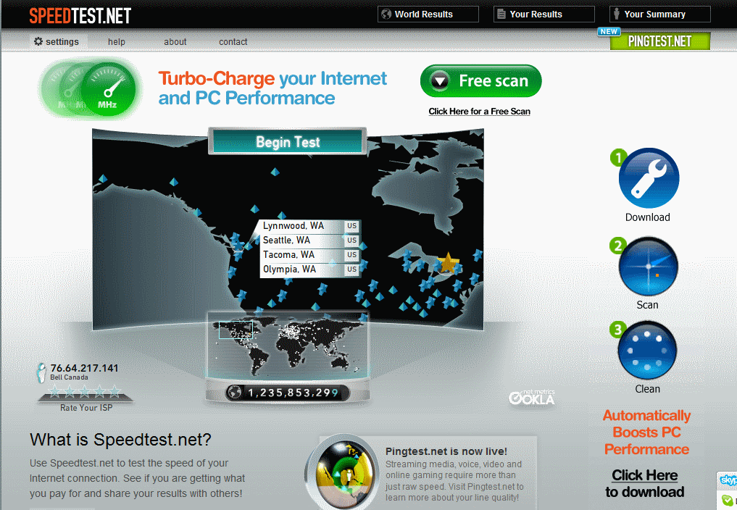
Then run the test by clicking “Begin Test”:
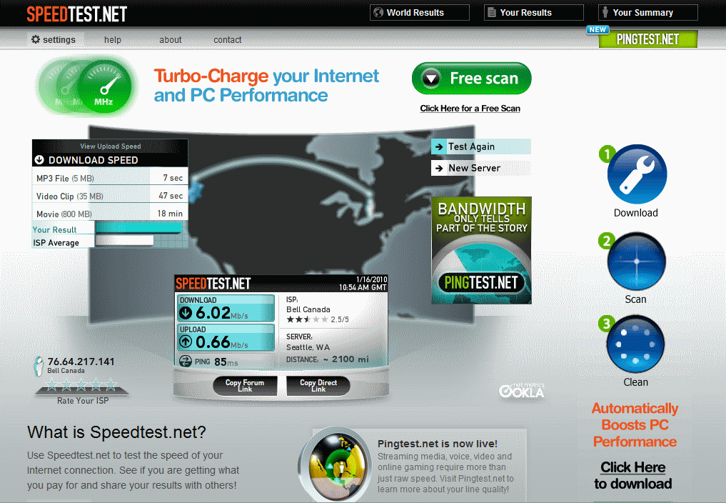

Software Installed
Java is required – when you go to the CoroCall URL for the first time you may be requested to install it is already resident on most computers. You will be requested to install a small Vidyo applet required to run CoroCall. All in all five to ten minutes maximum should suffice for the install(s).

Contact Us
Feel free to contact Martin Harvey of Coroware at:
E-mail | mharvey@coroware.com
Phone N. America | 800.641.2676 x721
Phone - other | +1 425.818.8990 x721  0870 446 2676 X721 (UK)
Mobile | +1.425.802.2223
Skype | coroware_mharvey
Windows Live | martinharvey47@hotmail.com
Time zone | Canada ET – GMT/UTC – 5 hours
To meet | MyCalendar

