Example 1 Simultaneous display using integrated multimedia technology process of video, PowerPoint, IBM ViaScribe real time transcription capturing tool and a statistical package called SPSS. The output uses the RealPlayer application to simultaneously display all the media and includes audio of the video/transcription.

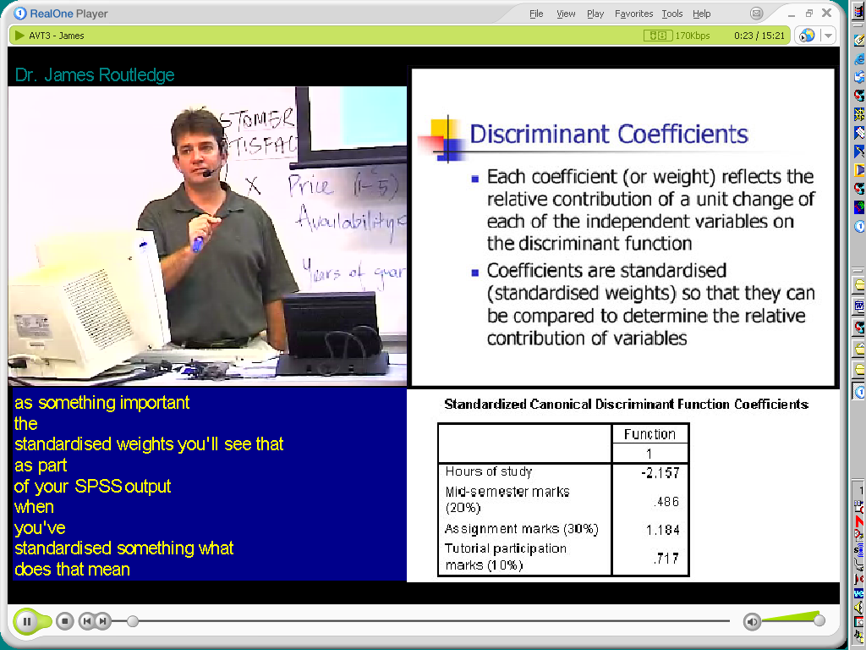

Example 2 – Automatic output into HTML with Audio, transcript and PowerPoint. with thumbnails



